System Design Document:

- Status HUD System
- The Status HUD is the primary interface layer for player data. It currently consists of the following functional sub-module:

- 1.1: Health Containers:
- 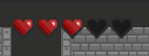
- Element: Heart Containers (Life Units) located in the Top-Left corner.
- Layout: Five (5) heart slots arranged horizontally.
- Visual States:
- Red Heart (Full): Represents 1 unit of active Health.
- Black/Empty Heart (Depleted): Represents a lost unit of Health.
- Current Status (per Screenshot): 3 Red Hearts, 2 Black Hearts (3/5 HP).
- Functional Logic:
- Damage: Red Hearts transition to Black from right to left upon taking damage.
- Healing: Black slots refill to Red from left to right upon recovery.
- UI Positioning: Anchored to the screen; remains static during camera movement.

2. Dungeon Environment & Room Layout
- This defines the physical boundaries and interactive gates of the gameplay area.
- 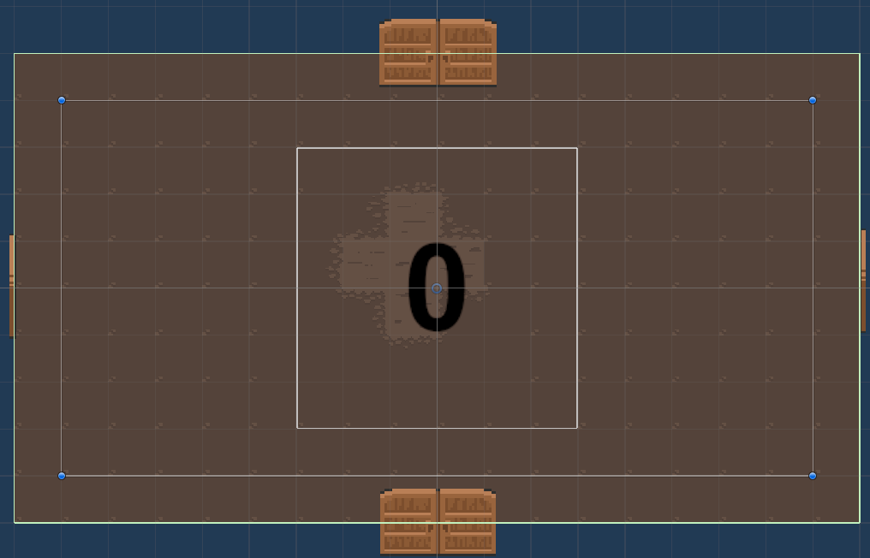

- 2.1 Spatial Structure (The Play Area)
- Shape: A fixed rectangular room enclosed by stone-brick walls (Tilemap).
- Floor Texture: Brown flat ground with a central cross-shaped darker wear-and-tear texture for visual orientation.
- Boundaries: Walls possess active Colliders to prevent the Hero and Enemies from exiting the designated play zone.
- 2.2 Gating System: Four-Way Directional Doors
- The room is designed with fixed door positions in all four cardinal directions: Top (North), Bottom (South), Left (West), and Right (East).
- Dynamic Presence: Each of these four positions may feature an active door depending on the room's connectivity within the dungeon layout.
- Interactive State - Open (Current): Doors are pushed outward to the sides, indicating a clear path for progression in that direction.
- Interactive State - Closed (Locked): Doors are shut, blocking exit until specific conditions (e.g., all enemies are defeated) are met.

